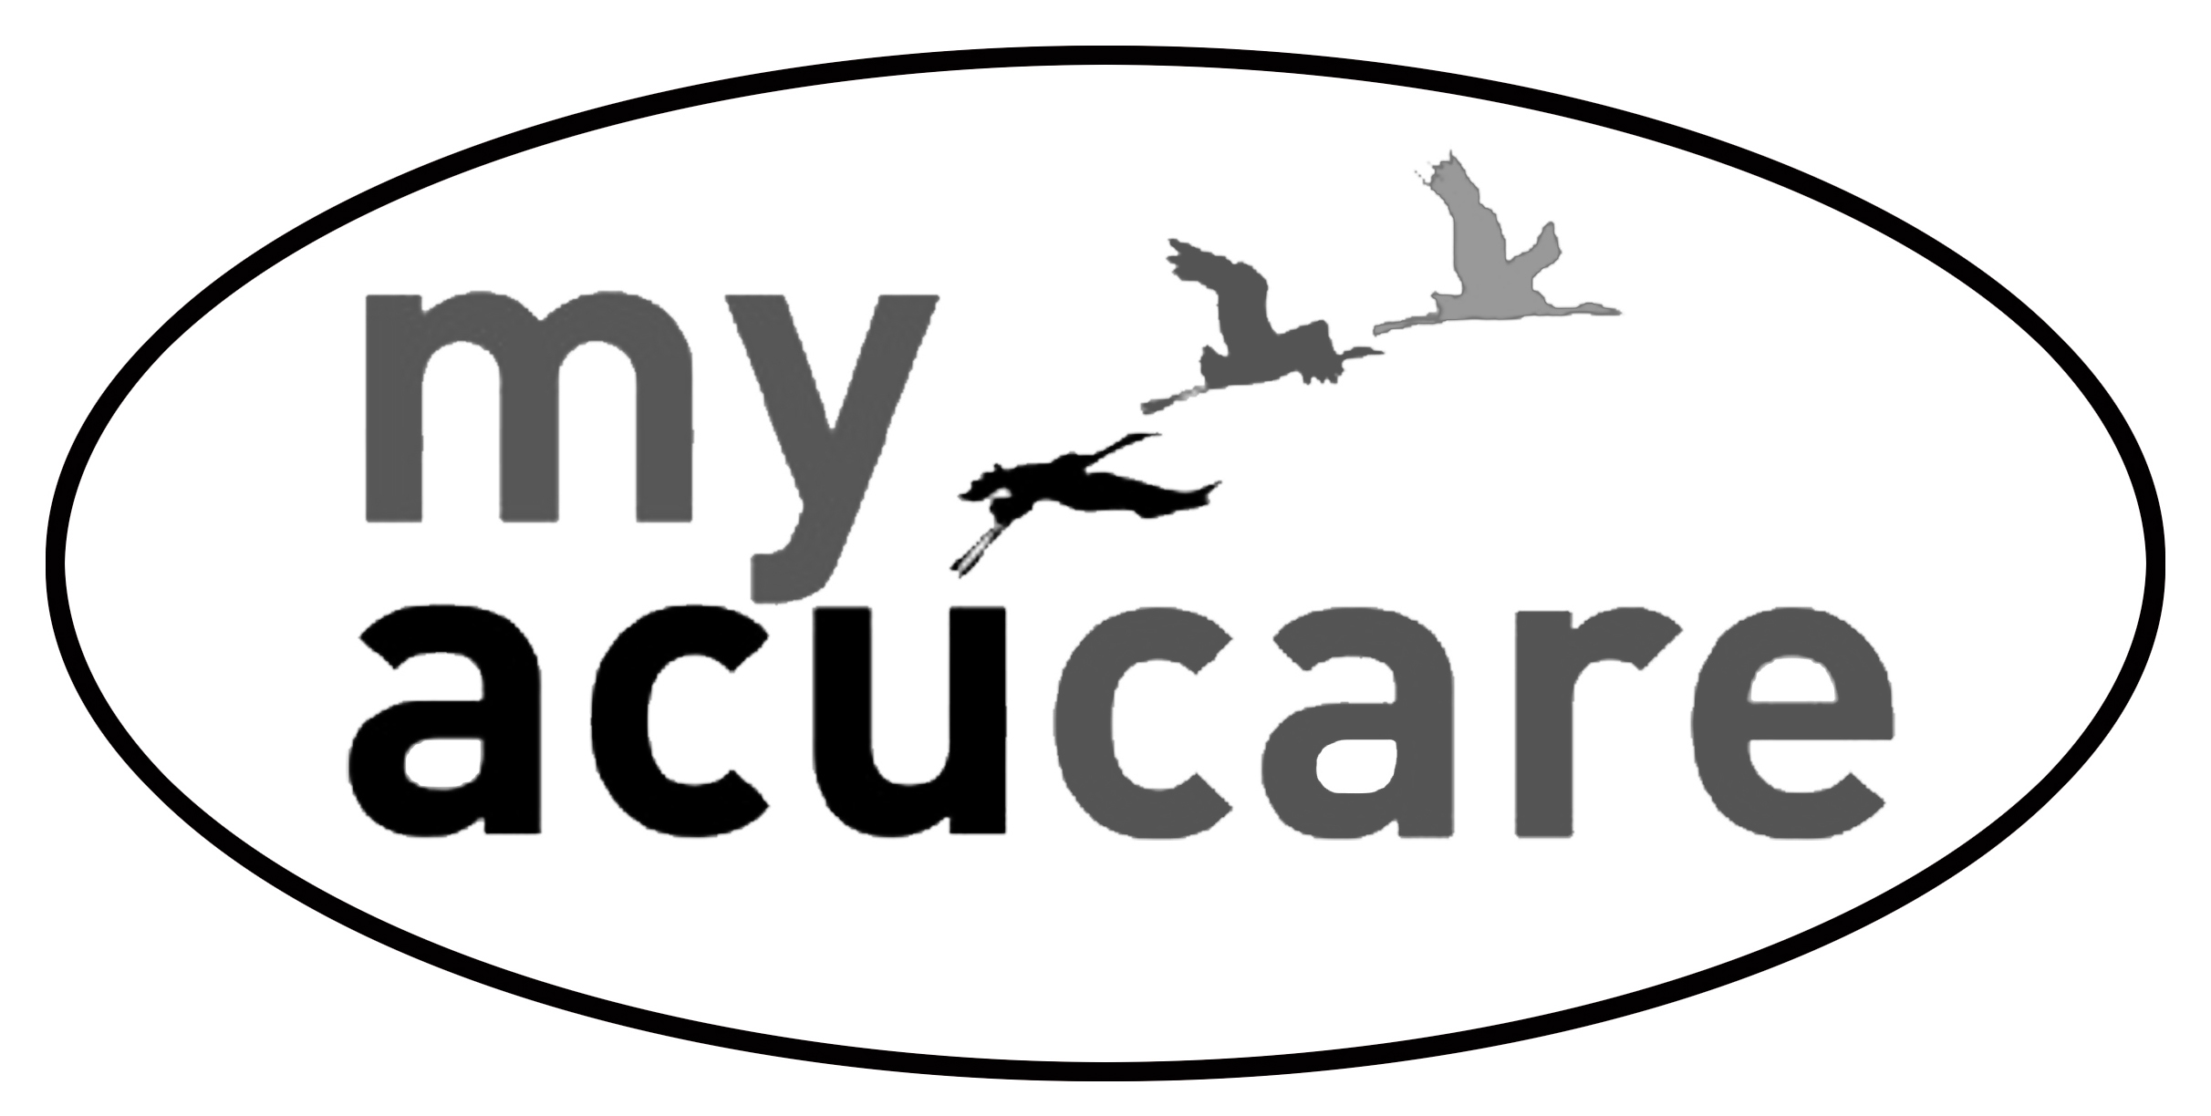Gaenor Farren-Smith MAcS

Health Information: Covid-19 Consent Form.

Name

Date

- Have you had a fever in the last 7 days? (feeling hot to touch on your chest and back. Or had a high temperature over 37.5)

Yes / No
- Do you now, or have you recently had, a persistent dry cough? (coughing a lot for more than an hour, 3 or more coughing episodes in 24 hours or worsening of a pre-existing cough)
Yes / No
- Have you been in contact with anyone in the last 14 days who has been diagnosed with Covid-19 or has coronavirus-type symptoms?
Yes / No
- Have you been told to stay at home, self-isolate or self-quarantine?
Yes/ No
- Do you have any other symptoms that may mean you have a Covid19 infection (eg. Loss of sense of smell, unusual fatigue or shortness of breath)
Yes / No
Consent for Treatment
I understand that, because my treatment may involve touch and close physical proximity over an extended period of time, there may be an elevated risk of disease transmission including Covid-19.
I understand that the practitioner cannot accept responsibility for the transmission of the Coronavirus (Covid-19) should I become infected.
I give my consent to receive treatment.
Signed:

Please email back to the practitioner at gaenor@MyAcuCare.co.uk

